##### 9008 Meisner Road, Casco, MI 48064 / [www.ourstjameschurch.org/](http://www.ourstjameschurch.org/)

Newsletter

April 2021

Volume 6, Issue 4

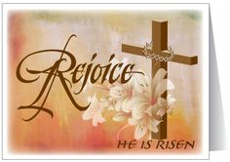

It just seems that everyone I talk to lately is experiencing winter fatigue. Even my consulting client that has had a banner year doing over a million dollars last year in corporate snowplowing and landscaping (mostly snowplowing) has informed me that he is “so done with winter.”

Many of you have commented or inquired about Easter being early this year. Not really. It just came rather late last year. We have had both earlier and later Easters. Well here is how it was decided. We can thank our Pagan friends in part for this. In 325CE the Council of Nicaea established that **Easter** would be held on the first Sunday after the first full moon occurring on or after the vernal equinox. From that point forward, the **Easter** date depended on the ecclesiastical approximation of March 21 for the vernal equinox.

Here is what I know for sure. Spring and Easter are here even though it may not feel like spring at this moment. I heard some folks discussing how many robins that have already seen (none at my house yet) and my neighbor mentioned that she already has crocus’, and I noticed little green sprouts popping up from beneath the cold earth as I walked through thinking about my gardens. It must be spring!!

As we finish this Lenten season the end of March and enter Easter, remember it is just like the transition from winter into spring. During what seems to be the endless cold dark days of winter, we start to experience the new life that rises up from what we were once sure was dead. That is what the Easter season offers us as well, to seek and experience new life, new life in our congregation and new life for ourselves

Contents

News from Pastor Ken 1

Pastor Ken News Cont. 2

Prayers Needed 3

Outreach Ministry 3

Birthday 4

Anniversary 4

Spiritual Ministry 4

Worship Ministry 4

Discretionary Fund 4

Earthly Gift Ministry 4

Easter Poem 5

Christmas Tote Bags 6

Ministers Needed 6

Bottle Can Collection 6

Military Prayer List 6

Kid’s Page 7

Activities 8

Scripture Readings 8



https://www.facebook.com/St-James-United-Church-of-Christ-10150090210425008/

# News from Pastor Ken

The purpose of a newsletter is to provide specialized information to a targeted audience. A school newsletter can be a great way to develop a strong relationship with parents.

First choose a short title for your newsletter— something like "School News," or “Back to School.” As you choose the title, also take time to think about the newsletter’s theme. What important messages do you want to send parents and families?

Next, establish how much time and money you can spend on your newsletter. These factors will help determine how frequently you publish the newsletter and its length.

Use the body of your school newsletter to keep parents apprised of major assignments and class events, as well as any of school district news. Also share news for specific grade levels, and tell parents about upcoming events, new faculty, and school policies.

## Dear Parents

St. James United Church of Christ

**Page 2 of 8**

This Lenten season was a powerful season for me as I hope it was for you, filled with reflection, preparation and discernment. Many of us spent time this Lenten season considering our own personal journey through the wilderness into Jerusalem. We prayed about what we bring to the cross and more importantly, what resurrection and transformation we have come to expect in our own lives this Easter. Over the past weeks, we have been talking about discovering the Christ within us, to be the resurrected, living Jesus we know God has called us to be.

As we come into spring, expect the miracle of new life. Expect to be transformed. Again, that is what Easter is all about. Some miracles are large and some are small, some require that we look for them. A number of them even require that we work to reveal them. However, if we do look, if we keep expecting them and are willing to do what God asks us to do; those miracles will just keep coming.

I am excited about what this Easter season has in store for us all, personally and as a community in Christ. I encourage you to keep your heart, mind and spirit open. Let us plan together, pray together, and work together. Let us prepare to be transformed.

I invite you all to participate in the Holy week services including Maundy Thursday, Good Friday, the Great Easter Eve Vigil and of course Easter morning Communion service. Invite those you have missed to join us and share in this time of personal transformation and renewal.

As always, who ever you are and wherever you are at on life’s journey, you are always welcome here.

Take care and be well, Peace

Pastor Ken

**\*\*Live streaming of Sunday Services will continue at 9:00am on the St. James Facebook page\*\***

**Pastor Ken Newsletter Continued**



Linda

Carole

Deborah

Karen

Barb

Janette

Rita

Ralph

Claudette S.

Wayne B.

Shirley

Keith

Sue

Terry

Doris

David

Lynn

Nikki

**Prayer List ….**

**Page 3 of 8**

**Outreach Ministry**

Helping Hands

**Current Needs:** No current needs at this time.

**No expired or opened boxes of food accepted**

Not accepting books and furniture at this time.

.

**Blue Water Area Rescue Mission** **– B-WARM**

**B-WARM NEEDS**

**Both Men and Women houses:**

No current needs. They are thankful for the church’s support and continued prayers. They’re trying to get back to normal after a year of COVID and family deaths.

**Current needs** are as follows:

Twin comforters, twin sheets, bath towels, hand towels, washcloths, Boys shorts size 5, boys jeans size 7, boys shirts size 6 (clothes new or gently used), boys and girls pajamas size 3 and up, boys and girls shoes, size 4 to 7 (especially size 2 boys), kids and adult toothbrush, toothpaste, baby body wash, shampoo, deodorant, adult body wash.

**Kids in Distress**

|  |
| --- |
| 7 – Tammy Czenkus |
| 9 – Wayne Baumgarten |
| 9 - Jason Szymanski |
| 12 – Butch Lomerson |
| 13 – Al Bryant |
| 29 – Christa Beattie |
| 30 - Frederick Erhardt |
| 30 - Douglas Bishop |

|  |
| --- |
| 4 – John & Marilyn Beattie |
| 8 – Dave & Becky Pittman |
| 20 – Mike & Bernice Callahan |
| 25 – Dan & Ellen Riley |

**Spiritual Ministry**

Sunday School is now in session. Please feel free to bring your children to church and partake in the weekly Sunday School classes.

Please contact Sue Tews if you are interested in helping with Sunday school.

**Happy Anniversaries in April**

## Happy Birthdays in April

**Page 4 of 8**

**Earthly Gifts**

Our goal for donations for April is $5852.00 temporarily.  As Treasurer I need your financial support to keep St. James in somewhat of a stable condition. Many do not know of the furnace problems and pipe bursting problems that have drained our finances, so please make the burden of paying our obligations as soon as possible by donating just a bit more by giving at service, Paypal or just dropping a check (no cash) in the mail to the church or me Ralph Ski, 8326 Meisner, Casco, MI 48064.  Thanking you so much in advance.

**The Discretionary Fund**

**April 4th, 2021**

Did you know this fund is utilized to aid with rent, utilities, medical supplies, food and transportation to doctors, etc.?

This is generated from the loose change collected the first Sunday of each month. Please empty your pockets and change purses that day to meet the needs of our church and community.

**Page 5 of 8**

Happy Easter!!!!

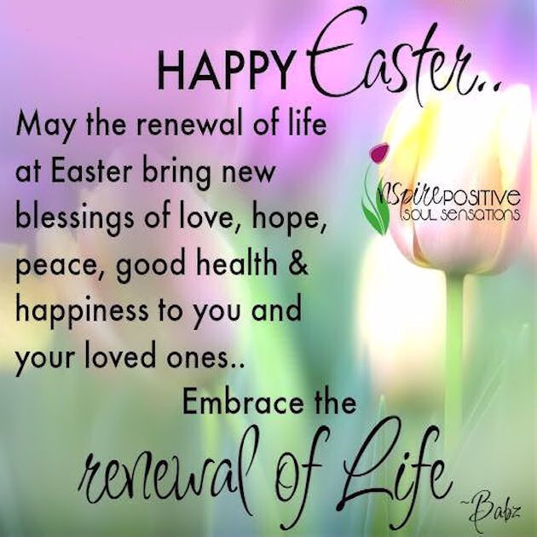

**Page 6 of 8**

**Christmas Tote Bags for**

**Local Community Charities**

The items accepted anytime: hats, gloves/mittens, scarves, TOYS, hygiene items such as: toothbrushes, floss, toothpaste, washcloths, headbands, barrettes and bows, socks (boys and girls, and school supplies.

We collect the below items for boys and girls from the age of 2 to 14 years old. Our goal is to **fill 100 tote bags for next Christmas 2021** without running out of items**.**

**April** items to collect are notebooks, crayons, colored pencils, glue, scissors.

**Ministry Needing Helpers!!!!!**

Members are needed to take the items received for donation to B-Warm, Kids-In-Distress and Helping Hands in Marine City, MI. As you see the boxes/tubs getting full please feel free to help in this ministry by taking the items to the designated places. **Call first**, to make sure they are open for deliveries.

B-Warm Kids-In-Distress Helping Hands

Bev & Gordie Kulman 310 s. Parker St.

1920 24th St 1114 S 7th St Marine City, MI 48039

Port Huron, MI 48060 St. Clair, MI 48079 (810) 765-3848

[(810) 956-0768](https://www.google.com/search?q=blue+water+area+rescue+mission+port+huron+mi&rlz=1C1CHBD_enUS725US725&oq=blue+water+area+rescue+mission&aqs=chrome.1.69i57j0.24248j0j7&sourceid=chrome&ie=UTF-8) [(810) 326-4505](https://www.google.com/search?rlz=1C1CHBD_enUS725US725&ei=j-5pW5X5EJCwsAW8gi4&q=kids+in+distress&oq=kids+in+distress&gs_l=psy-ab.3..0l2.106654.110108.0.110732.16.10.0.6.6.0.127.1111.1j9.10.0....0...1c.1.64.psy-ab..0.16.1140...0i131k1j0i67k1.0.DlX_ayFsvYg)



**Military Prayer List**

I will be including a list in the newsletter of our men and women in the military, to acknowledge those who serve and to pray for their safety. Please submit your love one’s, family member or friend’s name, rank and branch of service to Roberta Fisher to be placed on the list.

PFC Shane David Kinney Army Airborne

**Bottle / Can Collection**

Due to the circumstances right now, we will no longer be taking in actual bottle and cans. We are collecting cash donations from empty and clean bottles and cans you return to the store yourself that have a deposit on them to support our Christian Education Program.

Please bring the cash or a check to church. You may give Roberta Fisher or Ralph Ski the funds to give Betty Robertson. If you are unable to take them back, we will still take them at church for donation. Place them downstairs in the storeroom.

**Page 7 of 8**

**Kid’s Page**

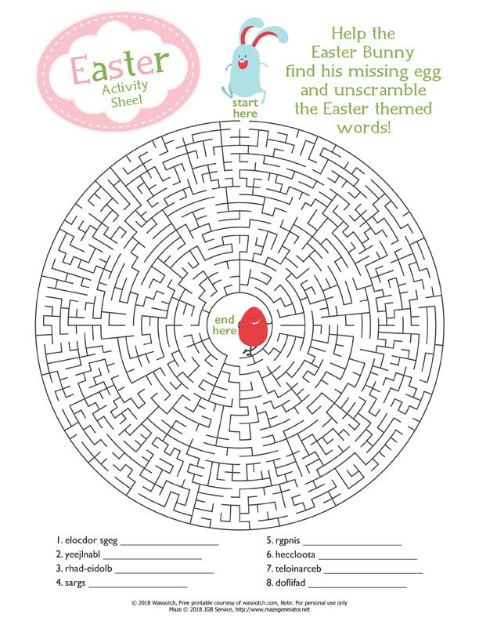

**April Activities**

**Page 8 of 8**

Thursday, April 1 – Maundy Thursday Service – at St. James 7pm

Friday, April 2 - Good Friday Services – St. James Service 12:00pm, Stations of

the Cross following service

St. Johns Service at 7pm, Stations of the Cross following service

Saturday, April 3, Holy Saturday Service at James – 7pm

Sunday, April 4 – Sunday Service with Holy Communion – at James - 9:00am

Discretionary Fund Collection

Easter Breakfast – Potluck at 8am before Easter service

Tuesday, April 13 – Council Meeting – 7pm

Sunday, April 11 – Sunday Service – 9:00am

Sunday, April 18 – Sunday Service with Holy Communion – 9:00am

Saturday, April 24 – Euchre at St. James – 6:30pm.

Sunday, April 25 – Sunday Service – 9:00am

## Scripture Readings for April

**Sunday, April 4 Sunday, April 11**

**Easter Sunday Second Sunday of Easter**

Acts 10 ; 34-43 or Isa 25 : 6-9 Acts 4: 32-35

118 ; 1-2, 14-24 Ps 133

1 Cor 15 : 1-11 or Acts 10 : 34-43 1 Jn 1: 1-2: 2

Jn 20: 1-18 or Mk 16: 1-8 Jn 20: 19-31

**Now What?**  **Marks of Faith**

**Sunday, April 18 Sunday, April 25**

**Third Sunday of Easter Fourth Sunday of Easter**

Acts 3: 12-19 acts 4: 5-12

Ps 4 Ps 23

1 Jn 3: 1-7 1 Jn 3: 16-24

Luke 24: 34b - 48 Jn 10: 11-18

**Christ Among Us**  **Enfolded by Love**

**St. James United Church of Christ**

**9008 Meisner Road**

**Casco, MI 48064**

**Phone:**

(586) 727--1623

**Fax:**

(586) 27-0833

**E-mail:**

kgadd@ourstjameschurch.org



APRIL

NEWSLETTER

